**MISY 5300**

**Assignment 5**

**USE: Oracle-SQL**

**Total Points: 20**

Instructions:

Login to the LiveSQL workspace.

**Number each query you create. Take a screen shot of your syntax for each query, then run the query and take a screen shot of the output, so you’ll be submitting two screen shots for each query. Number each screen shot, such as 1A and 1B for the first query, 2A, 2B for the second query, etc.** **Make sure each screen shot is large enough to be easily read and give its number.**

each department. Provide an alias DNAME for the department name column.

2. From the Departments table, display unique location IDs from the DEPARTMENTS table.

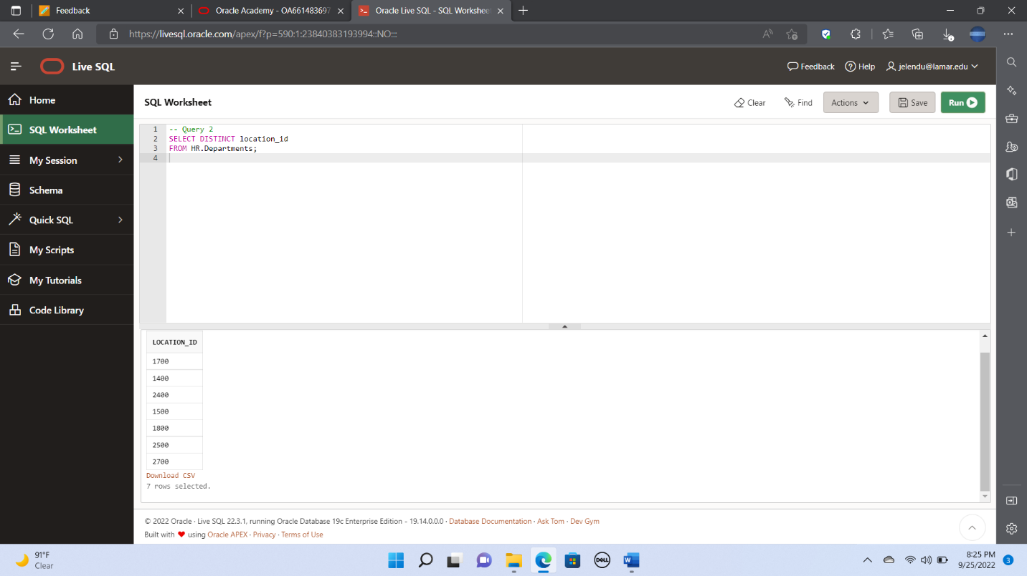

3. From the Countries table, display the country name concatenated with the region id, separated

by a comma and space, and name the column Country and Region.

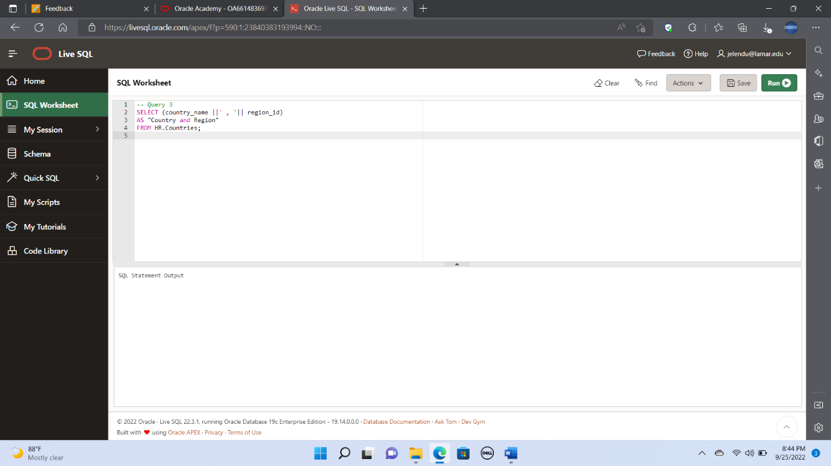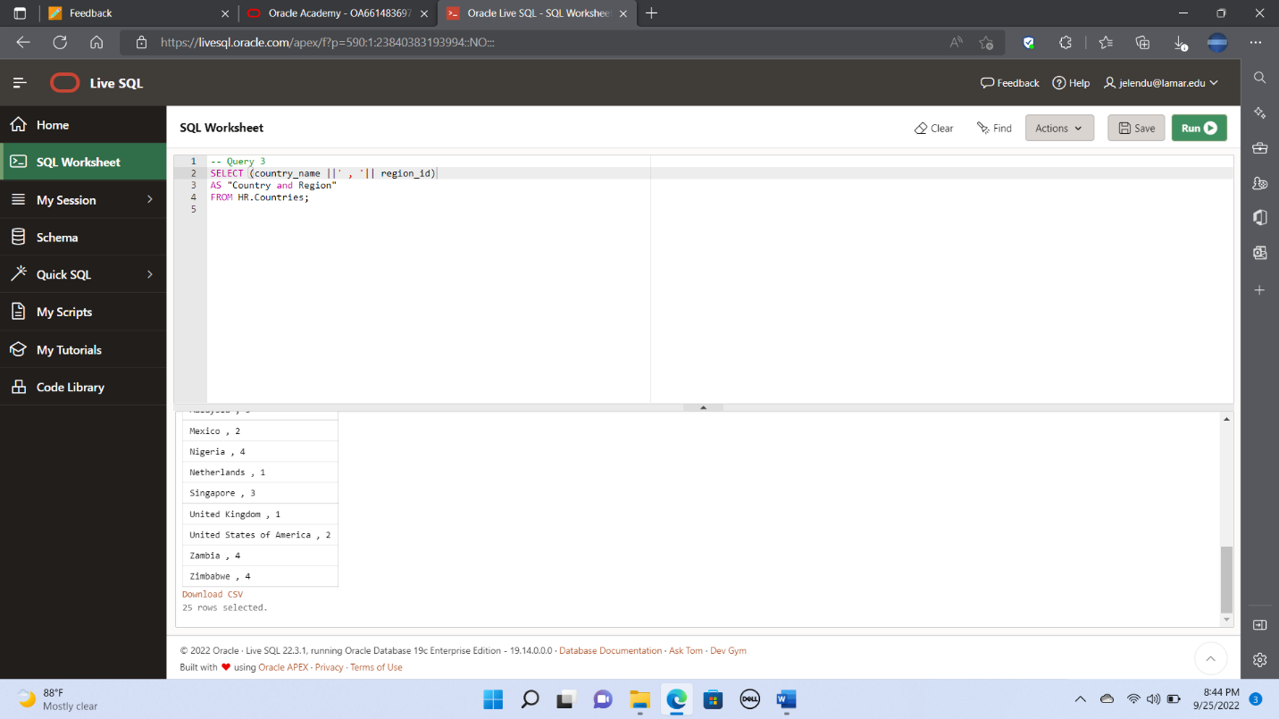

4. From the Departments table, display the department name and manager id for department id 60.

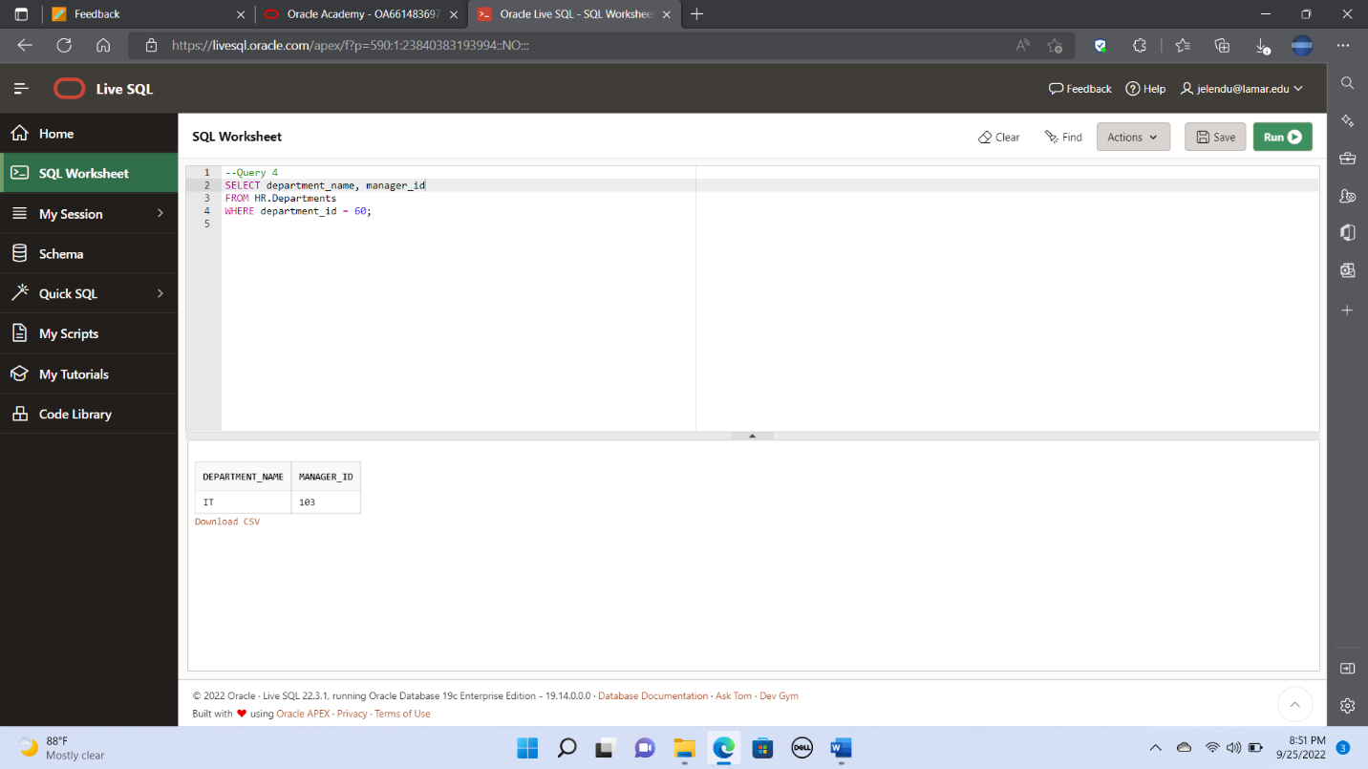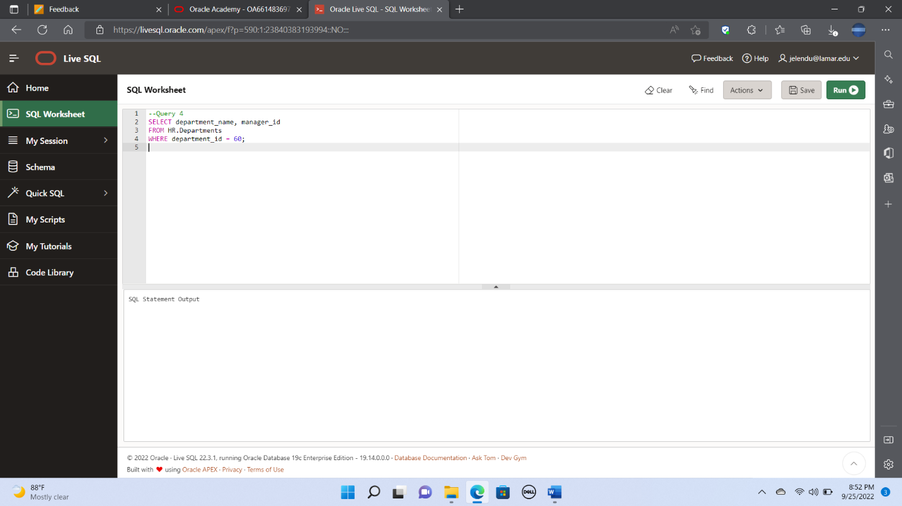

5. From the Employees table, display the last name, hire date, job id, and salary of all employees

whose salary is in the range of $8,000 - $15,000.

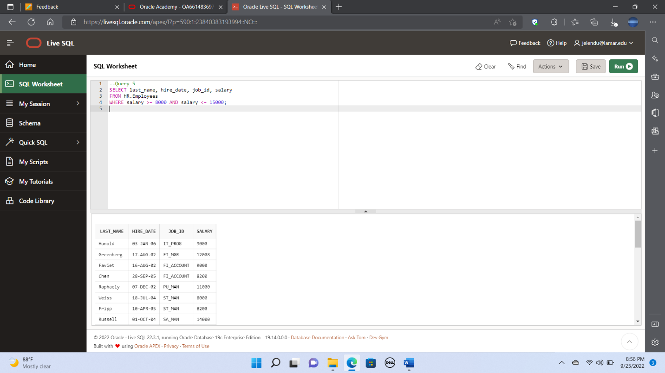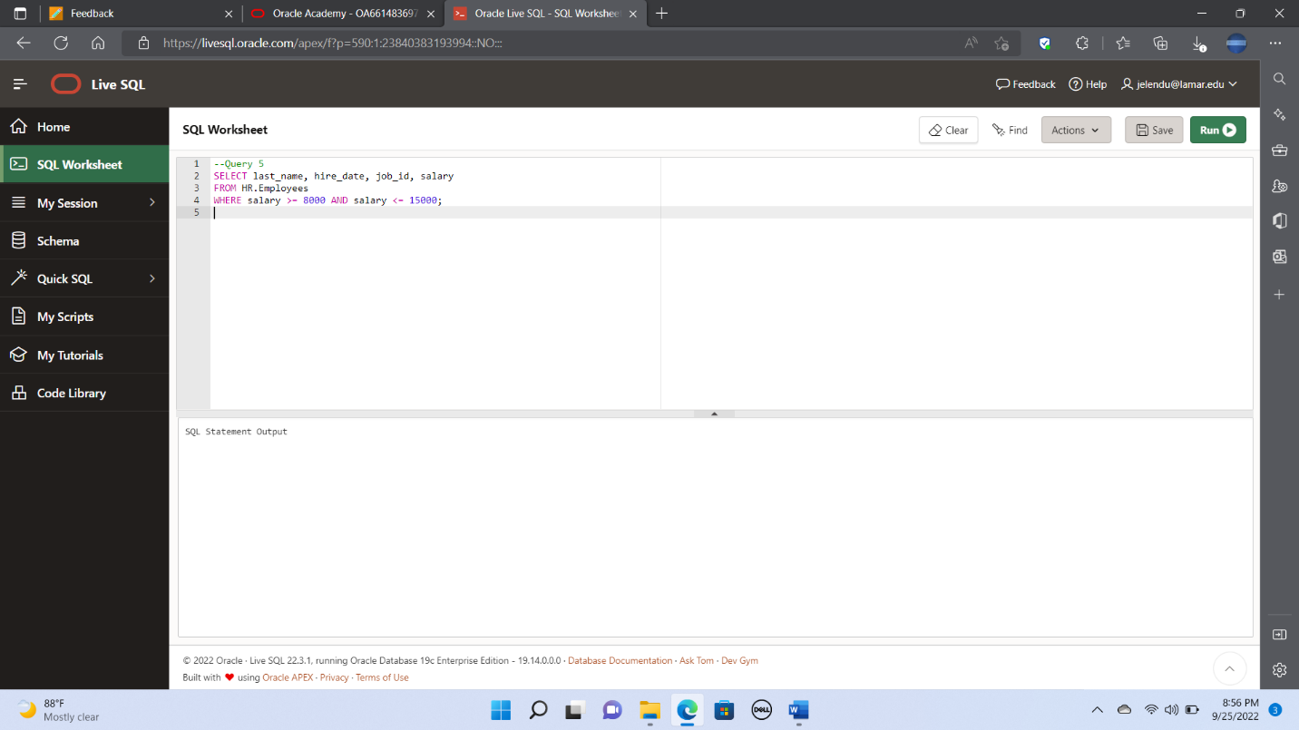

6. From the Employees table, display the last name and hire date of all employees who do not have

a manager.

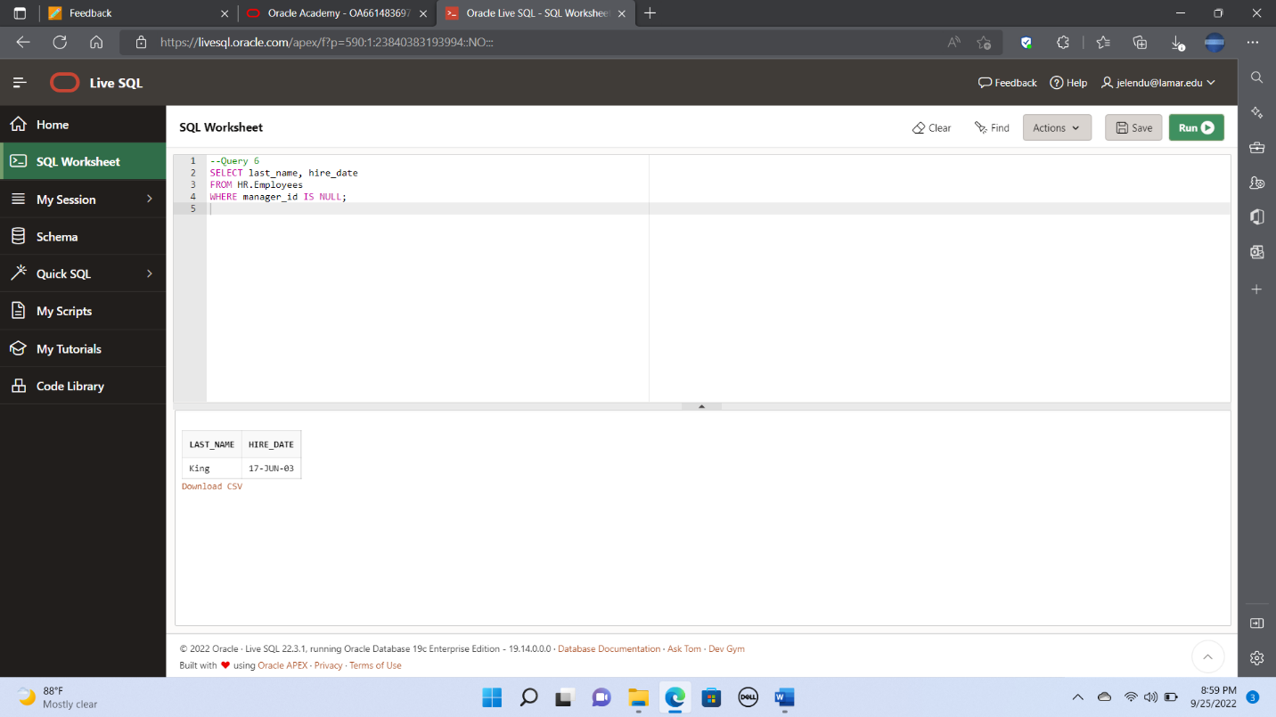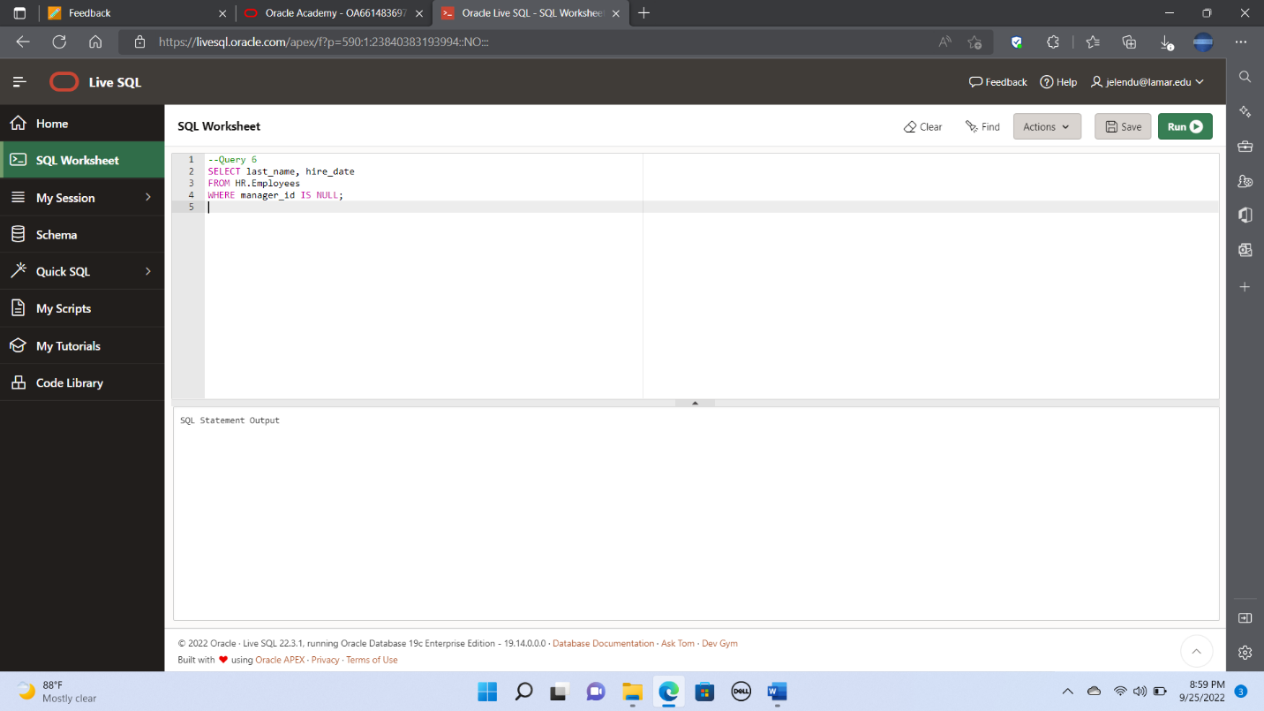

7. From the Employees table, for each employee, display the employee’s last name, and calculate

the number of months between today and the date the employee was hired. Label the column

MONTHS_WORKED. Order your results by the number of months employed.

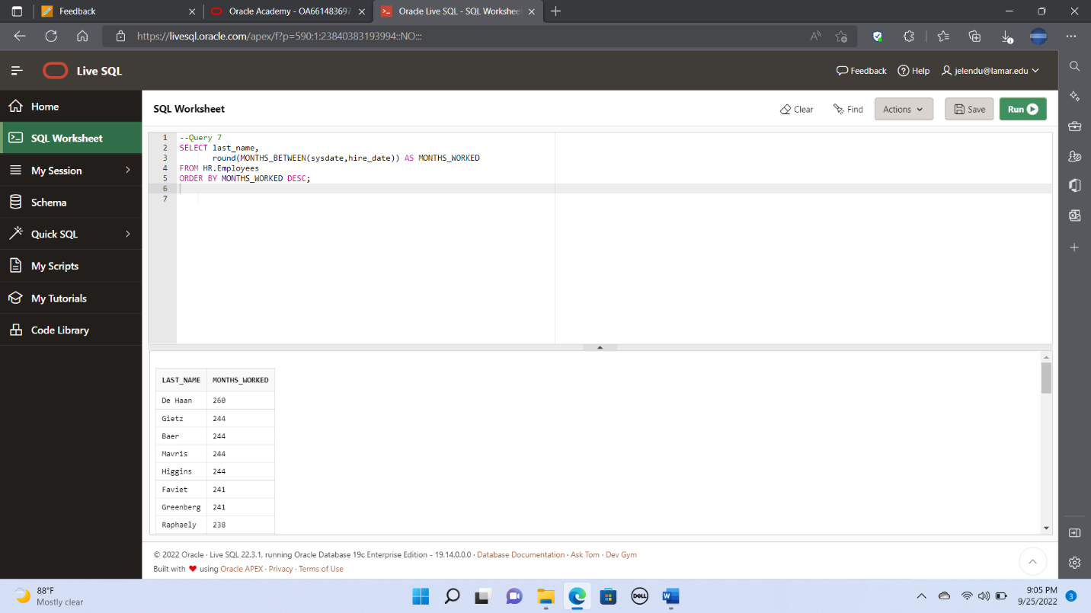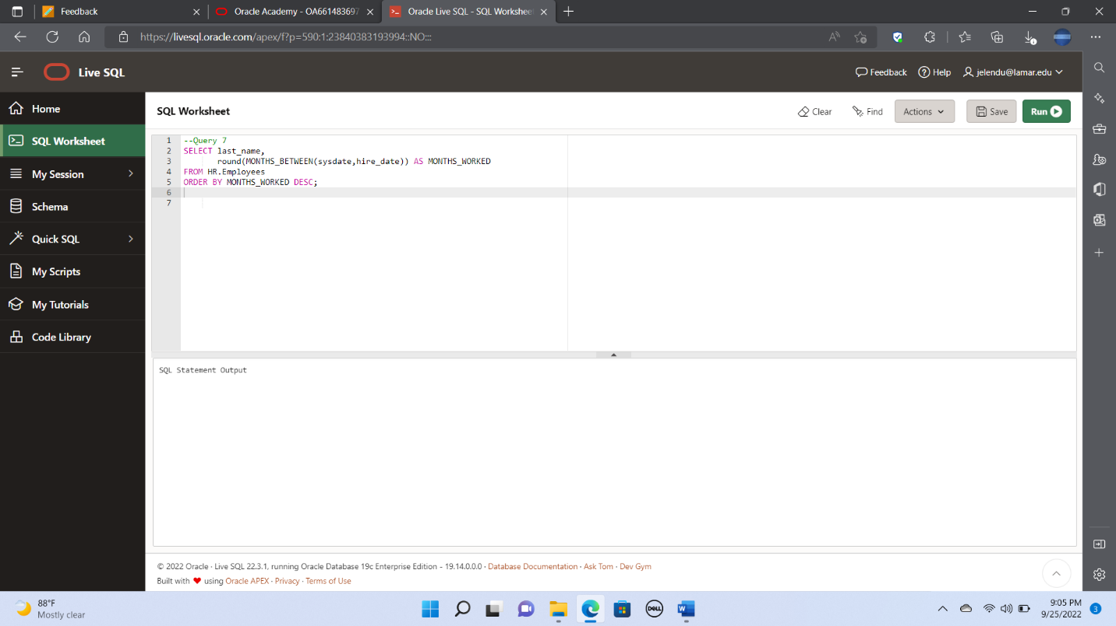

8. From the Employees table, for each employee, display the employee ID, last name, salary, and

salary increased by 12% and expressed as a whole number. Label the column New Salary.

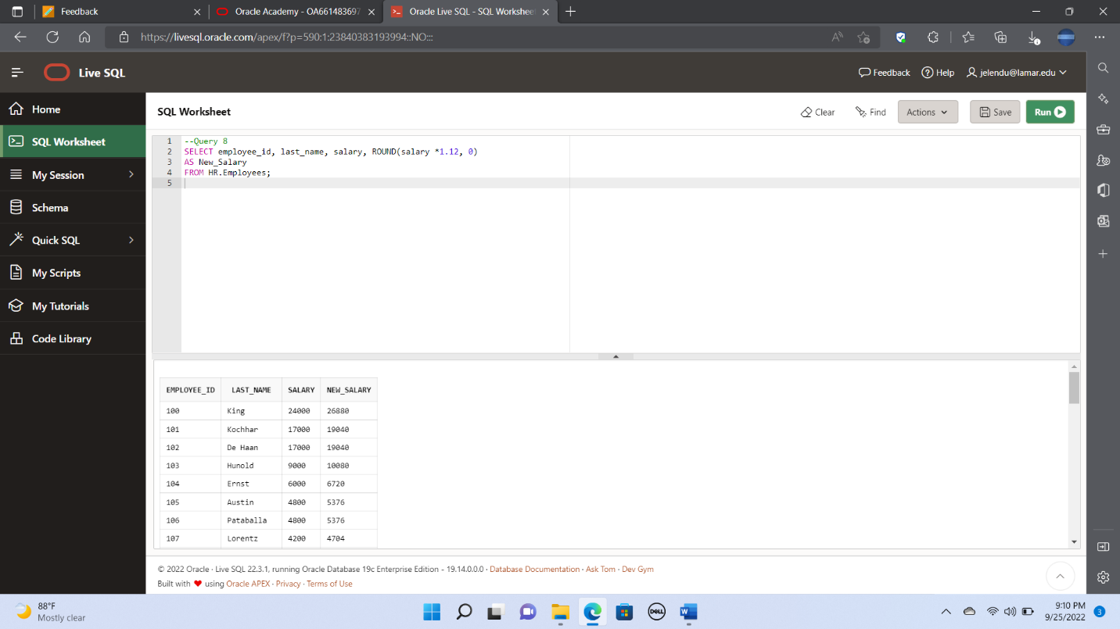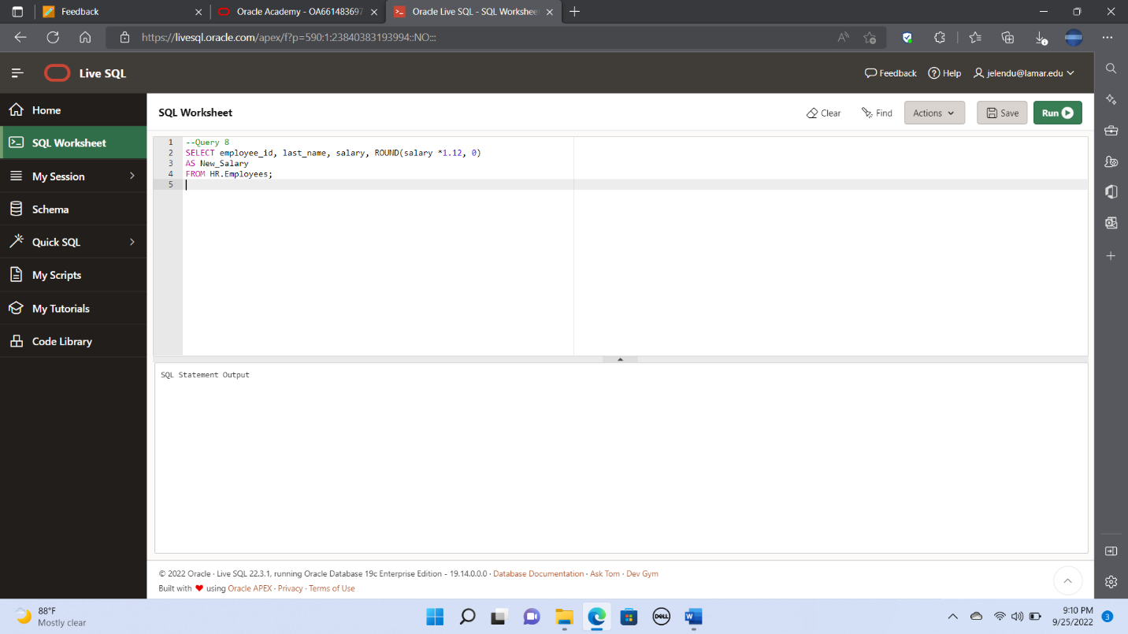

9. From the Employees table, display the employee’s last names and commission amounts. If an

employee does not earn commission, put ‘No Commission’. Label the column COMM.

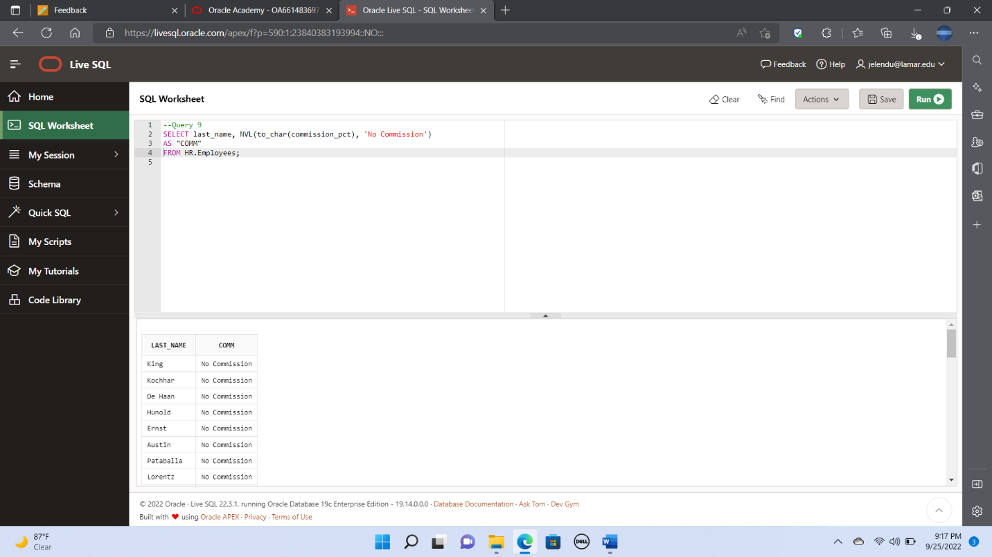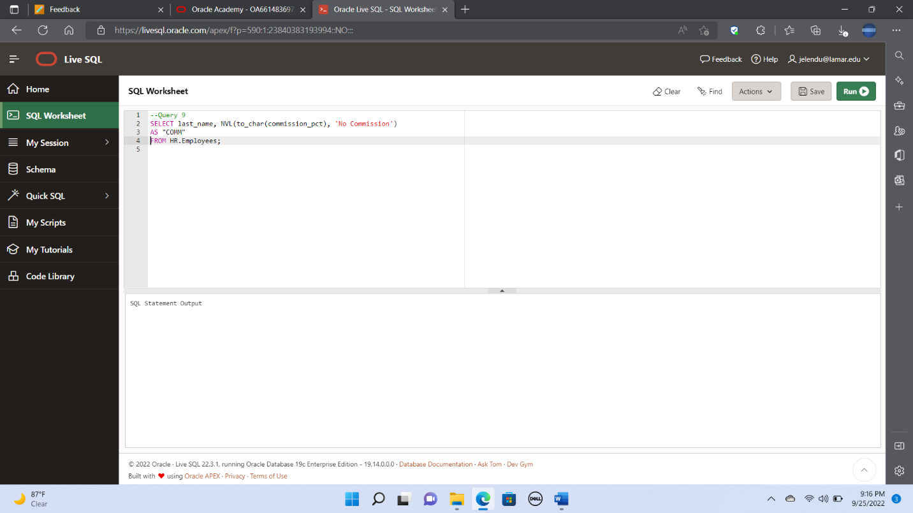

10. From the Employees table, display the last name, job id, and salary for those employees whose

last names end with an **n**.

